Activity: Weighted Planes
By Adrianna Macdonald

This activity explores how weight and gravity affects flight by discovering what happens when you add weight to paper planes. It leads into a discussion on how flying objects of all sizes, from the smallest fly to the biggest jet engine, overcome the force of gravity to achieve flight.

Materials:
Paper
Tennis ball or any kind of ball
Paper gliders
Tape
Small objects that can be used as weights (paper clips, coins, modelling clay, etc.)
Tape measure

Start off this activity with a demonstration on gravity.
- Crumple up a piece of paper and hold it in one hand. Take a clearly heavier object (like a tennis ball) in the other hand. Ask, “Which one do you think will hit the ground first and why?” The student will likely think that the heavy object will hit first because it weighs more.
- Drop the items to the ground. They will both hit the ground at the same time. Was their prediction correct? Ask, “What made them hit the ground at the same time?” If they are unsure, explain that gravity on earth acts on everything equally. It doesn’t matter how heavy or light an object is, the force of gravity is always the same.

From the demonstration above, students may believe that adding weight to planes won’t have any affect, because gravity acts on all objects equally. Well, things are a little different in terms of flight. In order to stay in the air, the weight of planes must be overcome by lift. When weight is added to a plane, there must be more lift, or it will not stay up. The same thing applies to birds. The bigger the bird, the more lift they must create to fly. Lift will be explored in depth later on. To explore how weight affects paper planes, try the following activity:
- Have the student make a quick paper plane and give it a throw (you could help them make it if necessary). Place a marker (like a coin) where the coin landed. Ask “Do you think adding weight to the glider will affect its flight? Explain your thinking.” At this point they will probably think no due to the last demonstration.
- Have the student add some weight, like a paper clip or coin, to the plane and give it a toss from the same starting position as before. Did the glider go as far? Ask, “Did gravity act on the glider differently?”
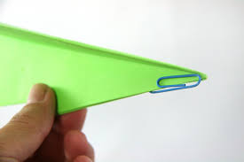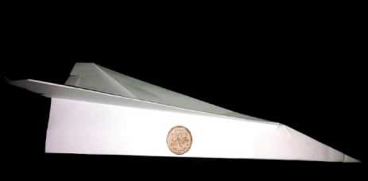\
- Pose the question, “What does adding weight to the paper plane do to its flight?”. Let them test this out by adding various weights to the plane and testing it. How does the weight affect the flying distance? Have them record the different weights added and the distance flown in the table below. A tape measure would be best for measuring distance.

Weight Added (ex: one coin) | Distance Flown (feet)

Have a discussion with the student on how the weights affected the distance flown. What patterns did they see? Ask them what they think would help the planes stay up longer. Maybe ask what the difference is between the wingspan of a small bird, and the wingspan of a large bird. What about the wings of a small plane vs a massive jet? How do they compare? Try and lead them into the conclusion that the shape and size of wings play a huge role in keeping all flying objects in the air. This is what we will be discovering next!

